**Design Document – Morgue Strikes Back**

*Attention: Due to deadlines a lot of the following in the Design Document had to be scrapped and not implemented. This was originally the goal and what the team had envisioned for the game.*

***Game Mechanics***

**Core Game Play - *A lot of content not implemented – Due to Deadline***

A zombie, *‘Maud’* trapped in a broken down morgue, realising he needs to escape. The morgue is filled with evil surgeons who are trapping souls from continuing onto the after-life. Maud’s job, to set the souls free by battling the syringe gun, surgical cleaver wielding surgeons with his intestine whip and his ability to throw skulls.

**Game Flow**

The player plays as the zombie character ‘*Maud’* the player works their way up through the broken down hospital, shooting and melee’ing surgeons who pose a threat to him. The player can move and jump throughout the level and once reaching an elevator go up it. There is cage’s scattered across the level with trapped souls that the player needs to collect in order to escape using the Golden Elevator. The player must avoid surgeons shooting at him by jumping or shooting them first, there are numerous holes throughout the layers of the hospital, falling would send the player back down. A surgeon can shoot the player with a syringe causing de-buffs, if a player kills a surgeon they can drop a syringe giving the player a buff.

**Characters**

*‘*Maud’ A simple zombie who has woken up inside a broken down morgue. Maud is a agent of Death who has commanded him to eliminate the surgeons who are keeping trapped souls in special soul binding cages.

‘Surgeon’ A basic enemy with a lot of comrades. All these surgeons contain a basic surgeon blade and a syringe gun that inflicts the player with de-buffs, and in return when killed drops a syringe containing a buff.

**Game Play Elements**

Players will be able to interact with cages to free souls, Elevators to progress up the level, Enemies to kill or be killed by and buffs dropped from enemies.

**Game Physics and Statistics**

*Movement –* The player will be able to move around and jump. There will be velocity and gravity affected the player’s movement. Faster velocity, faster player. Jumping depending on gravity, how long in air.

*Collision –* Players will be able to collide with multiple layers on the level. The platform layer will be the layer that the player actually walks on using collision. The background layer is for aesthetic purposes. The elevator layer will be a trigger layer that when players are near and press a button will move the player’s position. The enemy layer is where the enemy’s draw and their collision boxes. The bed layer *(Cage)* is where the player would be detected on it and free souls. The final layer, Golden, is the trigger layer for the golden elevator which would allow for the player to move to the next layer.

*Combat –* Combat will be about melee, if the hitbox of an enemy and player are near each other, the player will melee attack after the user inputs a key press. The hitboxes’ will then detect if they are near each other and if true the enemy will die. The other combat will be the ranged combat with bullets, the bullets will collide into the player or enemy and kill them.

**Artificial Intelligence**

The AI in the game is in the enemy’s. The enemy’s will walk around an area and then once a player is in sight attempt to shoot them. The enemy will also try to melee attack the player.

**Multiplayer *– Definitely not implemented.***

The hope for multiplayer would be able to have multiple zombies, using the same keyboard progressing throughout the level working together.

***Target Audience***

**Artificial Intelligence**

The game is based at teenagers and over. The game is not a kids game due to game being more dark and death oriented. The game would be for school kids who can’t play games in class but still do and a flash game is perfect for that. The game is also great for young adults just as a sit back and relax adventure game.

***Task Milestones***

***(Didn’t really happen like this – The dream)***

*Week 1 –* By week one the game will have a player being drawn, a level being designed, a lot of art sources being made and found, some game states, setting up the trello and github and organising roles.

*Week 2 –* In week two the game will have physics implemented into the game, player movability, level finished and drawing *(delayed)*, sprite’s and collision of the player with the level.

*Week 3 –* Week three will have the player with the ability to shoot from what direction he is looking, some HUD elements drawing, some sound implemented, trigger zones for the level, enemies drawing.

*Week 4 –* By week four the game will have enemies with their own AI with shooting and melee’ing, melee’ing for the player some final game state works, level 2 finished and drawing with level switching, sound effects, all HUD elements, win and lose conditions.

*Week 5 –* Week five is the final week of production, this will be the slight touch ups including sound, game states working correctly, testing and finally submission.

***User Interface***

**Flowchart**

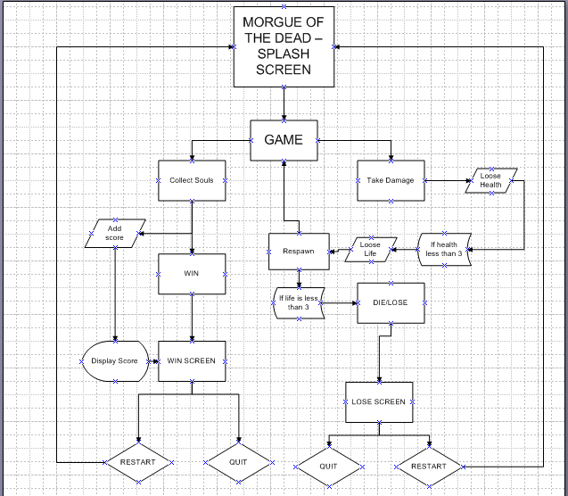

**Functional Requirements**

*Splash Screen –* The splash screen is the first thing the player will see. It will say the title of the game and press space to start.

*Game –* This is where the major game play happens, all the game play takes place here.

*Win Screen –* This will be the screen if the player fulfils the requirements to complete the game. Both Win and Lose will have a restart option.

*Lose Screen –* This screen is for if the player failed and died. Both Win and Lose will have a restart option.

**Mock-ups**

**Splash Screen**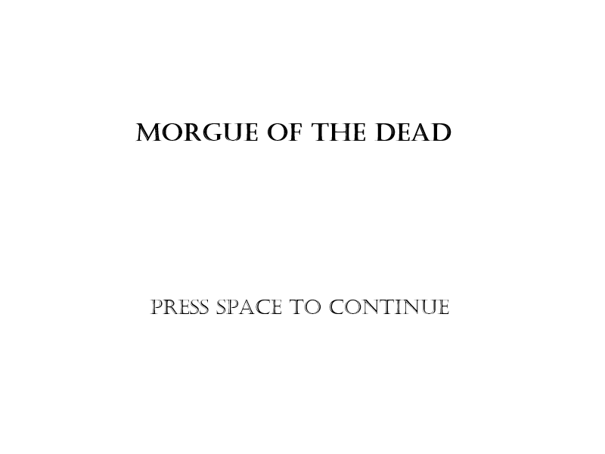

**Game Screen**

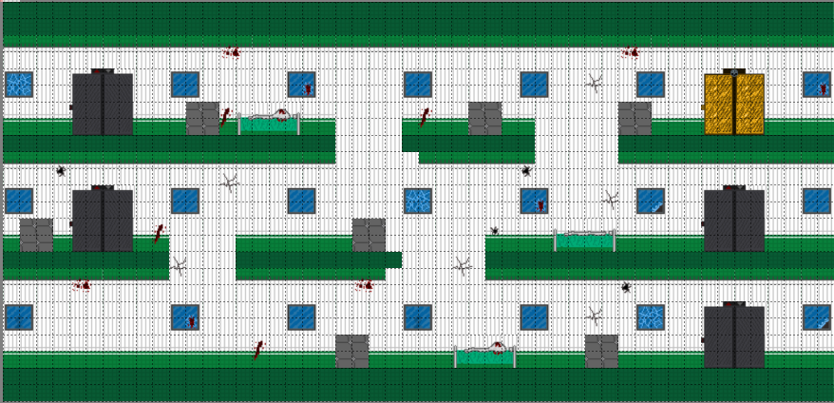

**Win Screen**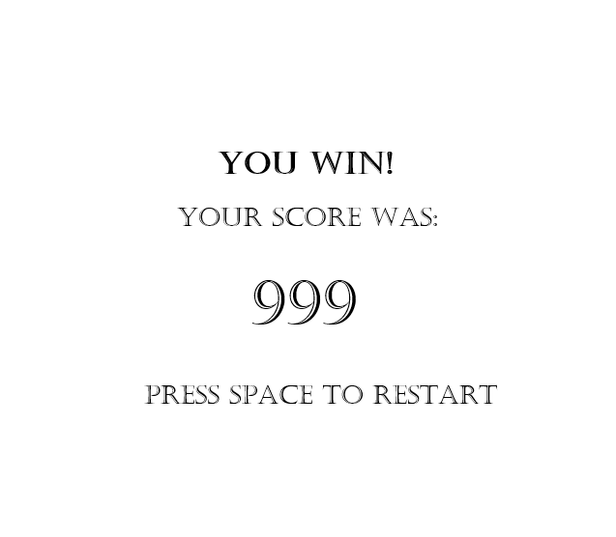

**Lose Screen**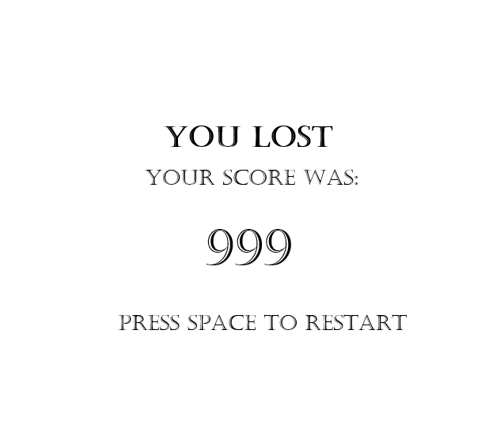

***Art and Video***

**Overall Goals**

A spooky and dark theme of sprites and tile sets, to go with the fact that Maud is a zombie fighting evil surgeons.

**2D Art & Animation**

All art has been custom made by the team. There are sprite sheets for, player, enemy and souls which you collect. There is a tile set for the level including a variety of tiles. Will have art for the health, score and lives all represented by separate art.

*Player –* Player sprite sheet

*Health –* Brains

*Lives –* Player head

*Ammo –* Skulls

*Enemies –* Enemy sprite Sheet

*Tiles/Level –* Tile-set

*Souls –* Soul sprite sheet

*Bullets –* Skulls

**Terrain**

The game has background reminiscent of a hospital wall. It has windows and walls with different variations to add variety and show detail.

**Game Play Elements**

The player, enemy and souls all have sprite sheets with working animations.

The player has attacking, shooting, idling, walking and jumping.

The enemies have sprites for walking and stabbing.

**Special Effects *- Not implemented***

When the player takes damage in game a particle effect of blood will appear. Also projectiles will have particles.

***Sound and Music***

**Overall Goals**

The game has a eerie feeling to it, being a broken down hospital and the game very death oriented the game has very dark music.

**Sound Effects**

*Begin –* The game has a begin sound effect as soon as the game starts.

*Hurt –* When the player takes damage this sound plays

*Jump –* When the jump key is pressed the player jumps and this sound effect is played.

*­Lose – ­*When the player loser’s the game the lose sound effect is played.

­*Win – ­*When the player wins this is played.

*Shoot –* When the shoot key is activated a bullet is fired and this sound effect plays.

**Cinematic Soundtracks**

***Story***

Maud is called upon by his god, Death. Death has found out that there is an evil hospital trapping innocent lives from going onto the afterlife. As it is deaths job to bring them onto the afterlife he sends Maud the zombie. Maud is sent into the broken down morgue and is asked by death to free his souls and make new ones of the surgeons by defeating them. Maud must traverse through the floors of the hospital till he finds all souls and reaches the exit.